**Preparing for speaking assessments**

**Remember:**

You’re not being tested on how well you can memorise a page of French or Spanish – if you learn the key words & some key phrases, you should already know the ‘building blocks’ (connectives, opinion phrases etc) that you need to put them together in sentences.

**Pronunciation:**

Before you start practising it, make sure you know how to say all of the words correctly – use text-to-speech for help and write the correct pronunciation above any words you had to check.

**Things NOT to do:**

* leave it to the last minute!
* panic!
* not practise at all because you think you’re rubbish so there’s no point!
* not say it out loud at all!
* stare at a page of writing for hours, hoping it will magically transfer itself to your mouth for the assessment!

**Things that could help you**



1. **Sentence builder**

* Say one sentence.
* Then say it again, and add a second one.
* Then do the first, second and then a third…
* Then the first, second, third and fourth....
* Make a fill the gap exercise where little by little you create more gaps.

1. **Get someone to test you**

* Practise a short section and get

someone to test you as if you

were learning a script for a play.

* They don’t need to understand what it means, they just have to is listen to what you say and see if the sound matches the words on the page. They can prompt you if you forget.
* This is a good way to get family members to help you, even if they don’t speak any French.

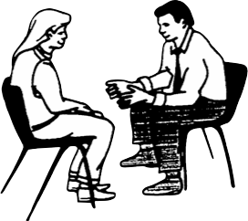

1. **Sing it**

* Fit the words to a rhythm or tune
* Sing it / rap it / put it to music.
* Use a tune you like or make one up.



1. **Act it out**

* Pretend the assessment is part of a play you are in and that your draft is your script.
* Think of gestures/actions to help you remember the key words/phrases.
* Put tone and emphasis into your voice.



C:\Documents and Settings\greens.BRUNTCLIFFEHS.001\Local Settings\Temporary Internet Files\Content.IE5\92X5BT5U\MC900324804[1].wmf

**5. Record yourself**

* Record yourself reading it out (make sure you know the correct pronunciation first).
* Play it back again and again and speak along with it, or keep pausing it and see if you

can remember what to say next.

* Play it on the bus, while walking the dog, while sleeping, while playing a computer game, while eating chocolate....