Listos 1 – Module 4 Extension tasks

Task 1
Design and label your dream house. Remember be creative if you want your house to have a pool and a helipad or a 10 car garage go for it!! Draw it as a birds eye view and label the rooms then colour it.
If you don’t have access to a dictionary, but have access to the internet www.wordreference.com is a great online dictionary!!

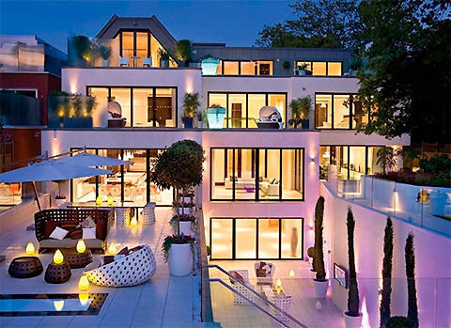
Key Vocab.

abajo = downstairs
arriba = upatairs
fuera = outside
mi dormitorio = my room
un aseo = a toilet
un cuarto de baño – a bathroom
un dormitorio = a bedroom
el dormitorio de mis padres = parents room
el dormitorio de mi hermano = brothers room
un salón = living room
un garaje = a garage
un jardín = a garden
un comedor = a dining room
un pasillo= a corridor
una cocina= a kitchen
una terraza = a terrace
un balcón = a balcony
una piscina = a pool

Task 2
Vocabulary test.

Key Vocab
un armario = a wardrobe
un equipo de música = a sound system
una lámpara = a lamp
una cama = a bed
una alfombra = a rug
una estantería = a bookshelf
un ordenador = a computer
una mesa = a table
una silla = a chair
una televisión = a TV
una puerta = a door
una ventana = a window
unos pósters = some posters

Task 3
Create a storyboard for your daily routine.

Key Vocab.

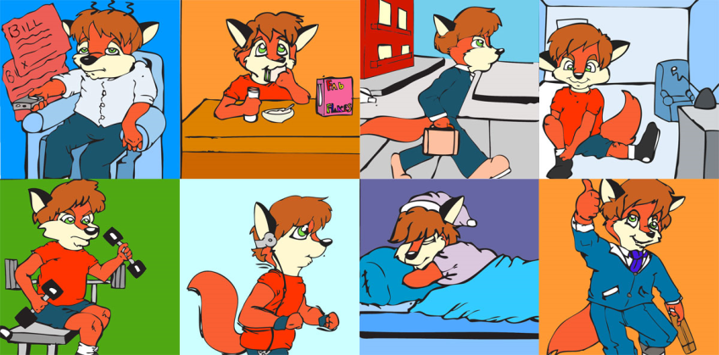
Duermo = I sleep
Juego con el ordenador = I play on the computer
Hablo por teléfono = I talk on the phone
Escucho música = I listen to Music
Mando mensajes = I send messages
Bebo Coca-cola = I drink coca-cola
Estudio = I study
Como bocadillos = I eat sandwiches
Leo libros = I read books
Veo la televisión = I watch TV
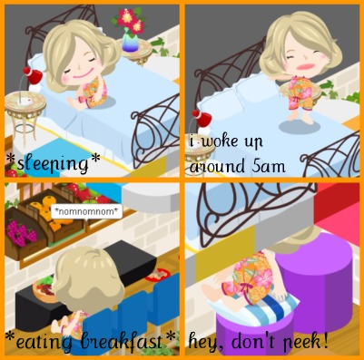
Navego por Internet = I surf the net
Por la mañana = In the morning
Me despierto = I wake up
Me levanto = I get up
Me ducho = I shower
Me peino= I comb my hair
Me visto = I get dressed
Desayuno = I have breakfast
Voy al instituto = I go to school
Por la tarde = In the afternoon
Vuelvo a casa = I return home
Ceno = I have tea
Me lavo los dientes = I clean my teeth
Me acuesto = I go to bed

